DAY 1 — REQUIREMENTS + ROLES
A. Requirements
1. Students can create a service request
2. Each request has title, description, and location
3. Each request has a status (Pending, In Progress, Done)
4. Students can view their requests
5. Staff can view all requests
6. Staff can update request status
7. Each request has a unique ID
8. The system stores request data
9. Users can view request details
10. The system validates input data
B. User Roles
1. Student:
- Create request
- View own requests
2. Staff:
- View all requests
- Update request status
DAY 2 — USE CASES
1. Submit Request
Use Case Name: Submit Request
Actor: Student
Trigger: Click "Create Request"
Main Flow:
1. Student enters title and description
2. System validates input
3. System saves request
4. System sets status to Pending
Success Outcome:
Request is created successfully
2. View Requests
Actor: Student
Main Flow:
- User opens request list
- System retrieves data
- System displays requests
3. View Details
Actor: Student
Main Flow:
1. User selects a request
2. System displays details
4. Update Status
Actor: Staff
Main Flow:
1. Staff selects request
2. Staff updates status
3. System saves changes

DAY 3 — SRP TABLE
Class | Responsibility | Reason to change
Request | Store request data | Data structure changes
RequestRepository | Handle database | DB changes
RequestService | Business logic | Rules change
RequestValidator | Validate input | Validation rules change
RequestController | Handle request flow | Routes change
ViewRenderer | Render HTML | UI changes

DAY 4 — UML
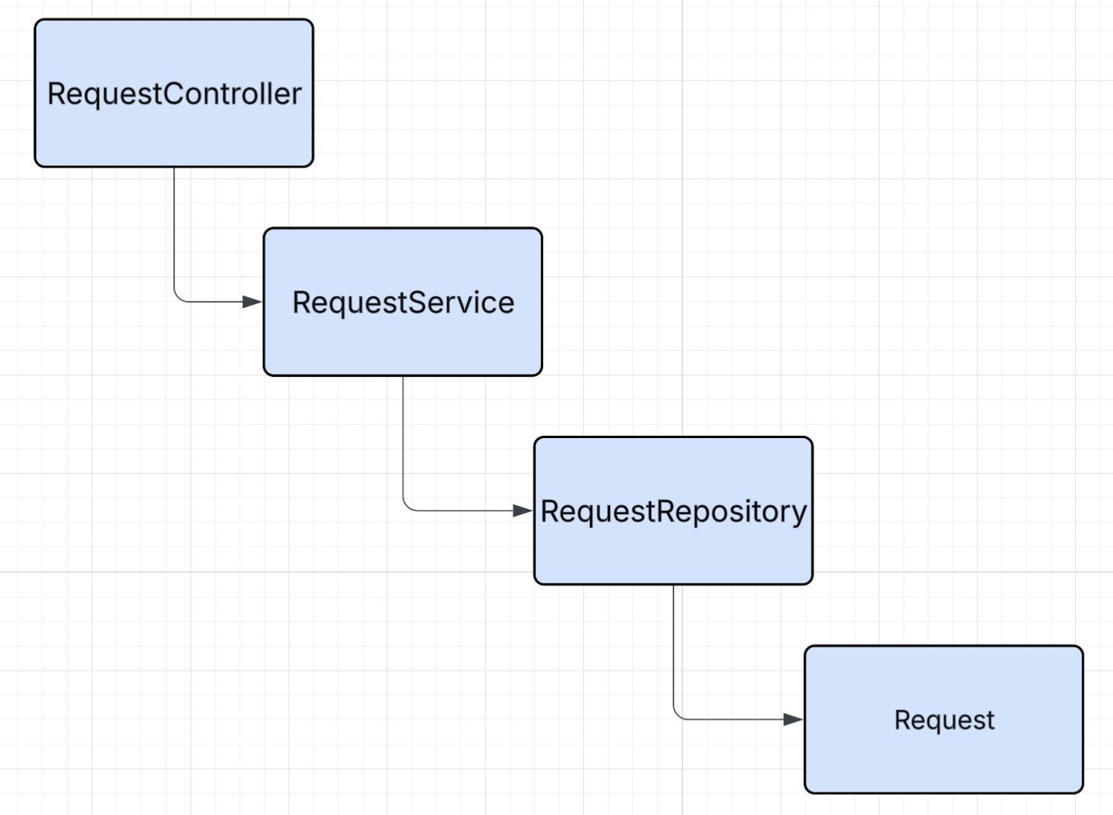

DAY 5 — MVC + ROUTES
1. MVC Mapping
Item | MVC | Why
Request | Model | Data
RequestRepository | Model | DB
RequestService | Model | Logic
RequestController | Controller | Handle request
index.php | View | Show list
show.php | View | Show detail

2. Route Table
Method | URL | Controller | Purpose
GET | /requests | RequestController@index | List
GET | /requests/create | RequestController@create | Form
POST | /requests | RequestController@store | Save
GET | /requests/{id} | RequestController@show | Detail
POST | /requests/{id}/status | RequestController@updateStatus | Update
GET | /staff/requests | RequestController@staffIndex | Staff view

DAY 6 — PSEUDOCODE
updateStatus(id):
get newStatus from user
call service.changeStatus(id, newStatus)
redirect to detail page
DAY 7 — REFLECTION
- Model includes Request, Repository, Service.
View includes index.php and show.php.
Controller is RequestController.
- Validation should be in RequestValidator to keep code clean and follow SRP.
- Putting SQL in View makes code hard to maintain and breaks separation of concerns.
- Next week I will implement controllers, routing, and views to make the system work.

